ULTRASONIC TESTING REPORT
Company/Client |  | NCOC N. V. |  | Project |  | ESKENE WEST |  | Location |  | Gas1 Tr.1
Line No/Tag No: |  | A1-3211-GA-001-2”-A11-HC |  | Material |  | A333 Gr.6 |  | Día × Nominal Thickness |  | 2”×5.54mm
Procedure No: |  | QP-11-UTT-Q01 Rev 03  GOST 28702-90 |  | Calibration Block |  | Step wedge |  | Probe  S/N |  | D7908  1214571
 |  |  |  | Calibration block Range |  | 2.5-12.5 mm |  | Angle |  | 0º
Manufacturing Code |  | ASME B31.3 |  | Calibration Temp |  | +21º |  | Frequency |  | 7.5 MHz
 |  |  |  | Object Temp |  | +21º |  | Size |  | 5.1 mm
Acceptance Standard: |  | Acc. to the client specif. |  | Correction factors |  | n/a |  | Crystal |  | Dual
Surface condition |  | Coated |  | Couplant |  | UT Gel |  | Accuracy |  | ± 0,1 mm
S. No | Equipment/  Material Name |  | Manufacturer |  | Serial No |  | Calibration certificate No |  | Calibration Expiry date
 | DL-38 |  | OLYMPUS |  | 171421601 |  | BK-01-0674 |  | 20-03-2020
 | Step wedge calibration block 2214M |  | OLYMPUS |  | 0272 19 |  | - |  | -
Job description:

- UT spot check performed on line A1-3211-GA-001-2”-A11-HC (drawing KE01-A1-321-PG-P-DI-0716-001 )
- Inspection performed on East, West, South, North, Top, Bottom and Extrados from external.
Notes:
N/A – not applicable.
FSH - Full Screen Height

Inspection drawing
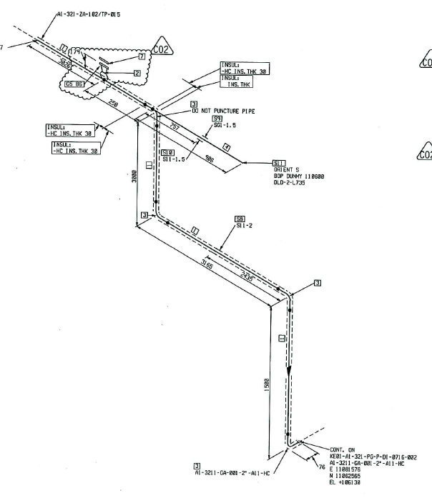
Flow
Leak area
- Leak
- UTT scan zone
- UTT Spot
Loc-1
Loc-3
Loc-2
Loc-4
Measuring the direction of the flow

S/NO | Line No | Item description | DIA(Ø), inch | Nominal thickness, mm* | East  mm | West  mm | South  mm | North  mm | Top  mm | Bottom  mm | Extrados  mm
1 | A1-3211-GA-001-2”-A11-HC | Loc-1(Pipe)  Spot-1 | 2” | 5.54 | 1.00 | 0.89 | - | - | 0.87 | 1.10 | -
2 | A1-3211-GA-001-2”-A11-HC | Loc-1(Pipe)  Spot-2 | 2” | 5.54 | 0.99 | 1.18 | - | - | 0.91 | 1.09 | -
3 | A1-3211-GA-001-2”-A11-HC | Loc-1(Pipe)  Spot-3 | 2” | 5.54 | 1.10 | 1.23 | - | - | 1.78 | 1.63 | -
4 | A1-3211-GA-001-2”-A11-HC | Loc-1(Pipe)  Spot-4 | 2” | 5.54 | 2.10 | 2.42 | - | - | 2.01 | 1.98 | -
5 | A1-3211-GA-001-2”-A11-HC | Loc-1(Pipe)  Spot-5 | 2” | 5.54 | 2.41 | 2.65 | - | - | 2.31 | 1.94 | -
6 | A1-3211-GA-001-2”-A11-HC | Loc-1(Pipe)  Spot-6 | 2” | 5.54 | 1.98 | 2.01 | - | - | 1.87 | 1.51 | -
7 | A1-3211-GA-001-2”-A11-HC | Loc-1(Pipe)  Spot-7 | 2” | 5.54 | 1.33 | 1.38 | - | - | 2.03 | 2.05 | -
8 | A1-3211-GA-001-2”-A11-HC | Loc-2(Elbow)  Spot-1 | 2” | 5.54 | 0.87 | 0.98 | - | - | - | - | 0.80
9 | A1-3211-GA-001-2”-A11-HC | Loc-2(Elbow)  Spot-2 | 2” | 5.54 | 0.55 | 0.84 | - | - | - | - | 0.67
10 | A1-3211-GA-001-2”-A11-HC | Loc-3(Pipe)  Spot-1 | 2” | 5.54 | 2.10 | 2.00 | 2.13 | 1.95 | - | - | -
11 | A1-3211-GA-001-2”-A11-HC | Loc-3(Pipe)  Spot-2 | 2” | 5.54 | 1.89 | 2.10 | 1.97 | 1.99 | - | - | -
12 | A1-3211-GA-001-2”-A11-HC | Loc-3(Pipe)  Spot-3 | 2” | 5.54 | 1.87 | 1.59 | 1.86 | 1.93 | - | - | -
13 | A1-3211-GA-001-2”-A11-HC | Loc-3(Pipe)  Spot-4 | 2” | 5.54 | 2.21 | 2.06 | 1.93 | 2.15 | - | - | -
14 | A1-3211-GA-001-2”-A11-HC | Loc-3(Pipe)  Spot-5 | 2” | 5.54 | 2.13 | 2.45 | 2.64 | 2.75 | - | - | -
15 | A1-3211-GA-001-2”-A11-HC | Loc-3(Pipe)  Spot-6 | 2” | 5.54 | 2.25 | 2.13 | 2.05 | 2.10 | - | - | -
16 | A1-3211-GA-001-2”-A11-HC | Loc-3(Pipe)  Spot-7 | 2” | 5.54 | 2.19 | 2.13 | 2.01 | 1.90 | - | - | -
17 | A1-3211-GA-001-2”-A11-HC | Loc-3(Pipe)  Spot-8 | 2” | 5.54 | 2.04 | 1.98 | 2.23 | 2.20 | - | - | -
18 | A1-3211-GA-001-2”-A11-HC | Loc-4(Elbow)  Spot-1 | 2” | 5.54 | - | - | 1.54 | 1.21 | - | - | 1.09

Inspection drawing
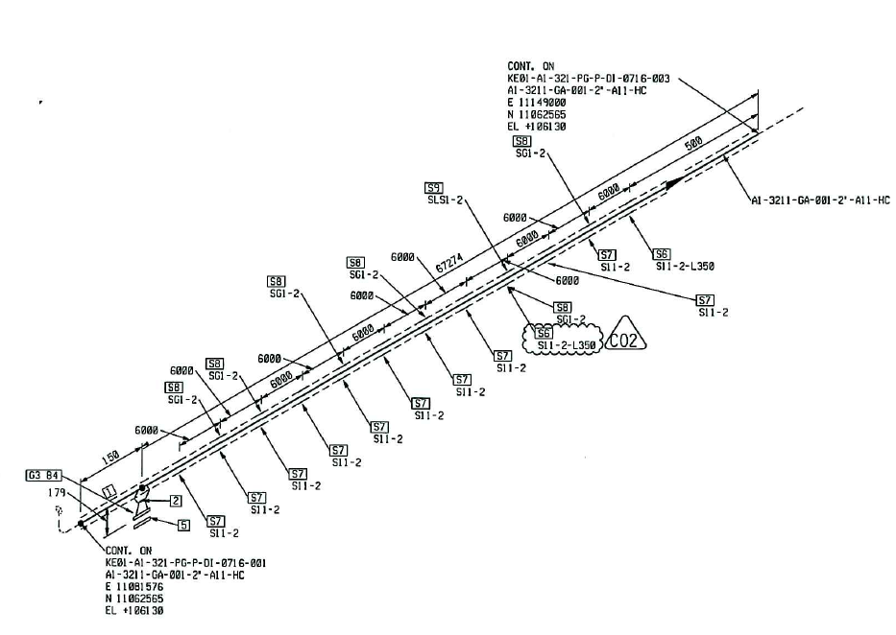
Flow
Loc-1
- UTT scan zone
Measuring the direction of the flow

- UTT Spot

S/NO | Line No | Item description | DIA(Ø), inch | Nominal thickness, mm* | East  mm | West  mm | South  mm | North  mm | Top  mm | Bottom  mm | Extrados  mm
1 | A1-3211-GA-001-2”-A11-HC | Loc-1(Pipe)  Spot-1 | 2” | 5.54 | - | - | 2.00 | 2.31 | 2.26 | 2.30 | -
2 | A1-3211-GA-001-2”-A11-HC | Loc-1(Tee)  Spot-2 | 2” | 5.54 | - | - | 2.89 | 2.91 | 2.93 | - | -
3 | A1-3211-GA-001-2”-A11-HC | Loc-1(Pipe)  Spot-3 | 2” | 5.54 | - | - | 2.49 | 2.69 | 2.46 | 2.33 | -
4 | A1-3211-GA-001-2”-A11-HC | Loc-1(Pipe)  Spot-4 | 2” | 5.54 | - | - | 2.41 | 2.94 | 2.89 | 3.12 | -

*according to ASME B36.10-B36.19 schedule 40

Examined by  UT L II cert. No 13180-2018-00 exp. date:11.07.2023 | Name: Ongarbayev Azimbek | Signature:............................... | Date: 26 September 2019
Approved by  UT L III cert. No 2B 189/16  expiry date 31.05.2021 | Name: Klindukhou Viachaslau | Signature: ............................ | Date: 26 September 2019
Client Representative: | Name: …………………………… | Signature: .............................. | Date: ………………………

